Year 6 Summer 1 | Key Dates
Big Question: How can we help the next generation?  Hook: we will launch the term with a community action project: designing persuasive posters and taking part in a litter pick around Southmere Lake to raise awareness about environmental responsibility. At the end of the week, we will hold a peaceful protest around the school and in the playground to share our message with others. | Lesnes Abbey history workshop: Wednesday 11th June  Lesnes Abbey Art Workshop: Wednesday 18th June  Lesnes Abbey procession and theatre performance: Thursday 26th June  KS2 Sports Day: Friday 27th June at 9:30am  WBP Festival: Friday 4th July  Spelling Bee: Thursday 10th July  Last day of term: Tuesday 22nd July


Subjects | Writing | Pupils will write a formal letter to their local MP about a local issue and create an informative leaflet promoting environmental awareness. | Core Text  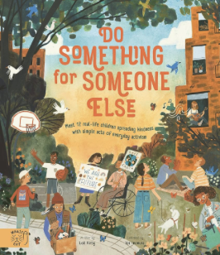
 | Reading | We will explore environmental poetry and read the core text Do Something for Someone Else, focusing on themes of kindness and responsibility.
 | Maths | This term covers decimals, volume, and units of measurement, with a strong emphasis on practical application and problem-solving.
 | Geography | We will study sustainability, including carbon footprints, climate change, and renewable versus non-renewable energy sources.
 | DT | Pupils will learn about upcycling by designing and creating protective covers for their iPads using recycled materials.
 | Arts fortnight | This term, we will be exploring the 1950s through visual art and dance. Pupils will take inspiration from the bold, expressive styles of Sister Corita Kent and Jackson Pollock to create both individual and collaborative pieces. We will also learn about popular dances of the era, including the hand jive and the Lindy Hop, bringing the spirit of the 1950s to life through movement and creativity.
 | Music | Children will build instruments from recyclable items and compose a group performance inspired by environmental themes.
 | Religious Studies | We continue exploring the question What would Jesus do? looking at parables and their relevance to modern-day moral choices.
 | Physical Education | This half term focuses on invasion games and tennis, developing teamwork, coordination, agility, and ball control skills.
 | Personal Development | We will explore emotional well-being, personal identity, and taking pride in who we are and what makes us unique.
 | Modern Foreign Language | The theme En la cocina (In the kitchen) introduces vocabulary for food, cooking, and describing meals and ingredients.
 | Computing | Pupils will deepen their understanding of networks and data, learning how digital information is shared and managed

