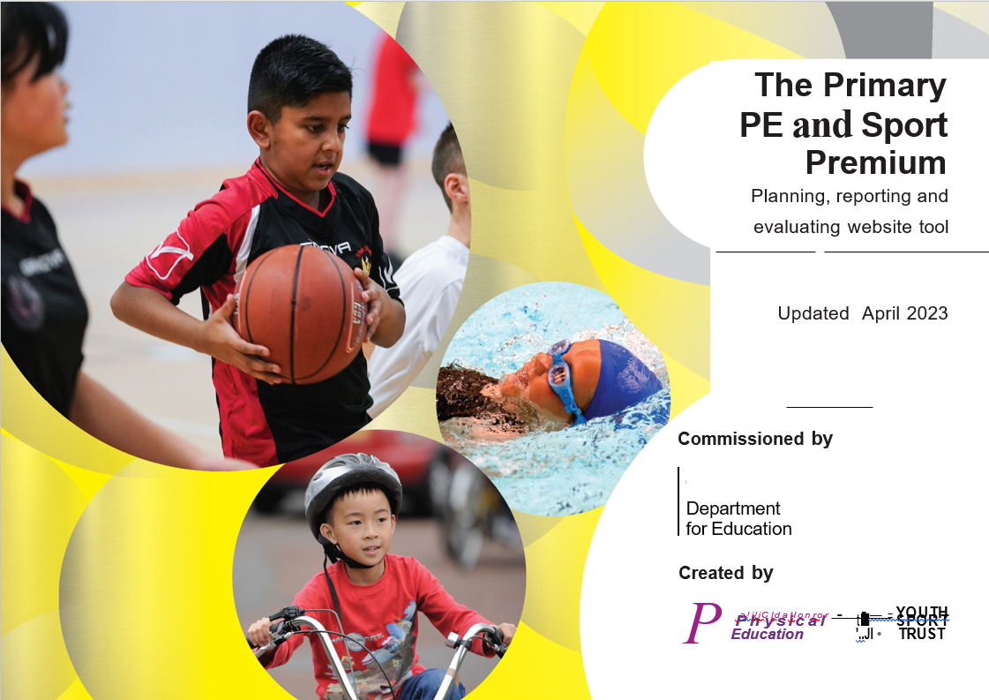
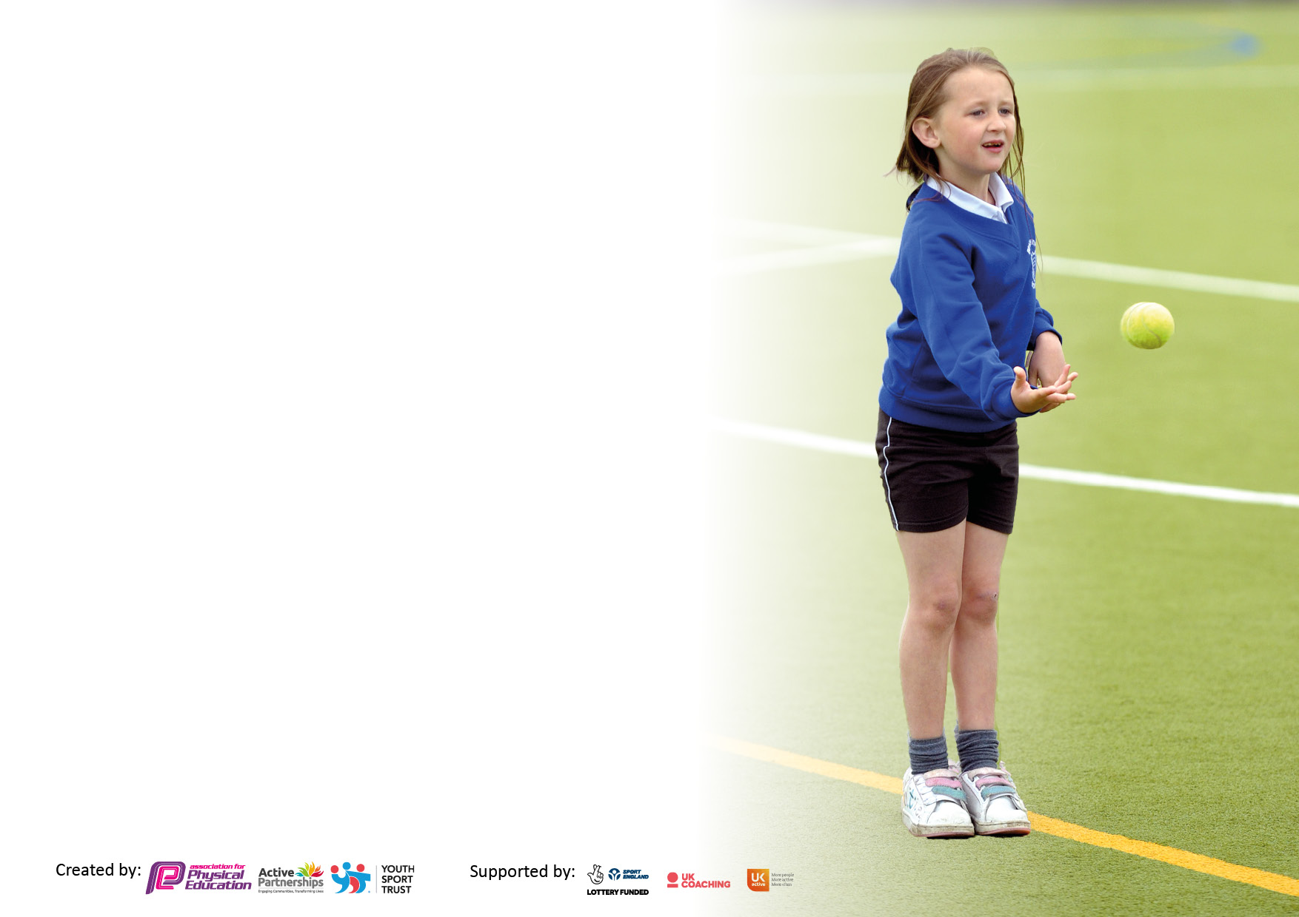

It is important that your grant is used effectively and based on school need. The Education Inspection Framework makes clear there will be a focus on ‘whether leaders and those responsible for governors all understand their respective roles and perform these in a way that enhances the effectiveness of the school’.

Under the Quality of Education Ofsted inspectors consider:
Intent - Curriculum design, coverage and appropriateness
Implementation - Curriculum delivery, Teaching (pedagogy) and Assessment
Impact - Attainment and progress

To assist schools with common transferable language this template has been developed to utilise the same three headings which should make your plans easily transferable between working documents.

Schools must use the funding to make additional and sustainable improvements to the quality of Physical Education, School Sport and Physical Activity (PESSPA) they offer. This means that you should use the Primary PE and sport premium to:

- Develop or add to the PESSPA activities that your school already offer
- Build capacity and capability within the school to ensure that improvements made now will benefit pupils joining the school in future years
- The Primary PE and sport premium should not be used to fund capital spend projects; the school’s budget should fund these.

We recommend you start by reflecting on the impact of current provision and reviewing the previous spend.

Schools are required to publish details of how they spend this funding, including any under-spend from 2019/2020, as well as on the impact it has on pupils’ PE and sport participation and attainment. All funding must be spent by 31st July 2023.

We recommend regularly updating the table and publishing it on your website throughout the year. This evidences your ongoing self-evaluation of how you are using the funding to secure maximum, sustainable impact. Final copy must be posted on your website by the end of the academic year and no later than the 31st July 2023. To see an example of how to complete the table please click HERE.
Created by: Supported by:

Details with regard to funding
Please complete the table below.

Total amount carried over from 2022/23 | £0
Total amount allocated for 2023/24 | £19,000
How much (if any) do you intend to carry over from this total fund into 2023/24? | £0
Total amount allocated for 2023/24 | £19,000
Total amount of funding for 2023/24. To be spent and reported on by 31st July 2024. | £19,000
Swimming Data
Please report on your Swimming Data below.

Meeting national curriculum requirements for swimming and water safety.

N.B. Complete this section to your best ability. For example you might have practised safe self-rescue techniques on dry land which you can then transfer to the pool when school swimming restarts.
Due to exceptional circumstances priority should be given to ensuring that pupils can perform safe self rescue even if they do not fully meet the first two requirements of the NC programme of study
What percentage of your current Year 6 cohort swim competently, confidently and proficiently over a distance of at least 25 metres?  N.B. Even though your pupils may swim in another year please report on their attainment on leaving primary school at the end of the summer term 2023.  Please see note above | % of pupils
What percentage of your current Year 6 cohort use a range of strokes effectively [for example, front crawl, backstroke, and breaststroke]?  Please see note above | % of pupils
What percentage of your current Year 6 cohort perform safe self-rescue in different water-based situations? | % of pupils
Schools can choose to use the Primary PE and sport premium to provide additional provision for swimming, but this must be for activity over and above the national curriculum requirements. Have you used it in this way? | No

Action Plan and Budget Tracking
Capture your intended annual spend against the 5 key indicators. Clarify the success criteria and evidence of impact that you intend to measure to evaluate for pupils today and for the future.

Academic Year: 2023/24 | Total fund allocated: | Date Updated: July 2023
Key indicator 1: The engagement of all pupils in regular physical activity – Chief Medical Officers guidelines recommend that primary school pupils undertake at least 30 minutes of physical activity a day in school |  |  |  | Percentage of total allocation:
 |  |  |  | 8%
Intent | Implementation |  | Impact
Your school focus should be clear what you want the pupils to know and be able to do and about  what they need to learn and to  consolidate through practice: | Make sure your actions to achieve are linked to your intentions: | Funding allocated: | Evidence of impact: what do pupils now know and what can they now do? What has changed? | Sustainability and suggested next steps:
Children further develop skills to lead as play leaders and take an active role towards promoting sports and PE  Lunchtime sporting clubs in place every day led by Sports Coach to support wellbeing and physical activity.  Varying sport equipment availed during lunch break for pupils to independently explore skills learned during physical education lessons.  Children are encouraged to walk to and from school to support with increased physical activity of all pupils. | Successful applicants will be provided with training to support their role as play leaders. Pupil interests and achievements outside of school will also be utilised to promote physical wellbeing.  Play leaders to take an active role in different sports activities with the support of adults on duty.  An overview of additional sporting activities in place and allocated to children to support both physical and mental health, along with resources to support this.  This is promoted by the Play Leaders within newsletters and assemblies. | £500  £1000
Key indicator 2: The profile of PESSPA being raised across the school as a tool for whole school improvement |  |  |  | Percentage of total allocation:
 |  |  |  | 8%
Intent | Implementation |  | Impact
Your school focus should be clear what you want the pupils to know and be able to do and about  what they need to learn and to  consolidate through practice: | Make sure your actions to achieve are linked to your intentions: | Funding allocated: | Evidence of impact: what do pupils now know and what can they now do? What has changed? | Sustainability and suggested next steps:
To provide children with the skills  and opportunities to use a range of  sports skills in different contexts. | PE passport ensures lessons focus on skills which can be transferred across the curriculum. Children will also be able to apply skills within Local Authority, inter Trust and local school competitions. | £1,000
PE continues to have a high profile within the school | Children’s achievements are celebrated each week during celebration assembly and parent newsletters.  Sports news regularly shared on website and social media.  Improving and growing the range of after school sport club provision. | £500

Key indicator 3: Increased confidence, knowledge and skills of all staff in teaching PE and sport |  |  |  | Percentage of total allocation:
 |  |  |  | 52%
Intent | Implementation |  | Impact
Your school focus should be clear | Make sure your actions to | Funding | Evidence of impact: what do | Sustainability and suggested
what you want the pupils to know | achieve are linked to your | allocated: | pupils now know and what | next steps:
and be able to do and about | intentions: |  | can they now do? What has
what they need to learn and to |  |  | changed?
consolidate through practice:
Teachers are provided with CPL through the deployment of specialist staff.  CPL opportunities are identified for teaching staff to observe high quality teaching of PE by sport coaches to enhance current provision in school.  Medium- and short-term plans in place to support the sequence of teaching and skills within each area of the curriculum. | Teachers are provided with opportunities to observe excellent practice and develop their own practice. Application, for development, within whole school sporting events and after school clubs.  Sports coaches provide CPD which is then used within daily lessons.  Staff are provided with opportunities to review lesson sequences on PE passport and review based on the needs of the children and school context and identified need. | £10,000
Key indicator 4: Broader experience of a range of sports and activities offered to all pupils |  |  |  | Percentage of total allocation:
 |  |  |  | 16%
Intent | Implementation |  | Impact
Your school focus should be clear | Make sure your actions to | Funding | Evidence of impact: what do | Sustainability and suggested
what you want the pupils to know | achieve are linked to your | allocated: | pupils now know and what | next steps:
and be able to do and about | intentions: |  | can they now do? What has
what they need to learn and to |  |  | changed?
consolidate through practice:
Pupils to access after school clubs to develop both physical and mental health, particularly focusing on those children who are most vulnerable.  Targeted groups in place to further develop the wellbeing of all children.  Use award programmes such as Children’s University to encourage children to get involved in lots of exciting activities including physical activities. | An overview of clubs for the year in place which provide a broad and balanced overview of the PE curriculum with opportunities for all year groups. Clubs to be subsidised to ensure all children have equal access. Pupil voice to inform the choice of clubs available throughout the year.  Pupils identified by the wellbeing team with support modelled around need and interests of the pupils.  Children participating in physical activities within or outside the school will be able to earn a stamp and with enough stamps graduate at the end of the academic year. | £3,000
Key indicator 5: Increased participation in competitive sport |  |  |  | Percentage of total allocation:
 |  |  |  | 16%
Intent | Implementation |  | Impact
Your school focus should be clear | Make sure your actions to | Funding
what you want the pupils to know | achieve are linked to your | allocated:
and be able to do and about | intentions:
what they need to learn and to
consolidate through practice:
Children are provided with competitive opportunities in school, across the Trust and with local primary schools. | Opportunities for competitive sports are identified and children are provided with additional coaching to support with this.  Interests of children identified and developed through applications to join different sporting leagues.  School based equipment is relevant and further enhance development of children.  Inter-Trust Competitions in place and reflect the current PE curriculum. Opportunities for competitive sports are identified and children are provided with additional coaching to support with this.  Keep a record of participants during sporting events to ensure that all pupils not just the active ones participate. | £3000

Signed off by
Director of Education: | Julie Carson
Date: | 12th July 2023
Subject Leader: | Abi Oldfield
Date: | 12th July 2023
Governor:
Date:

