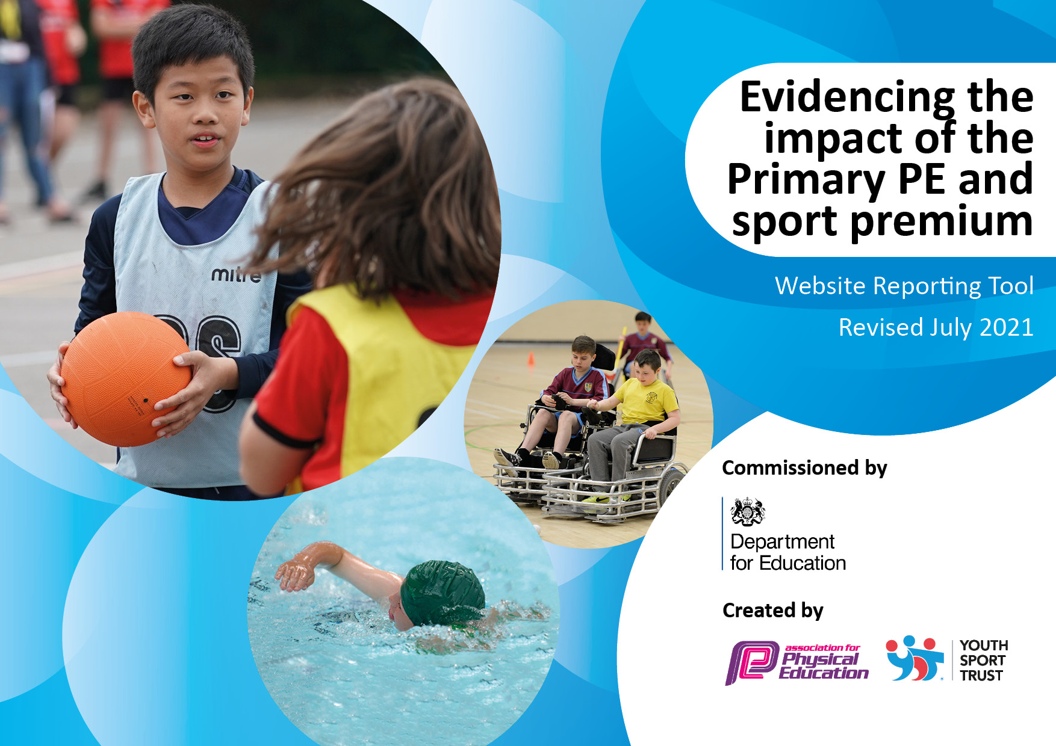

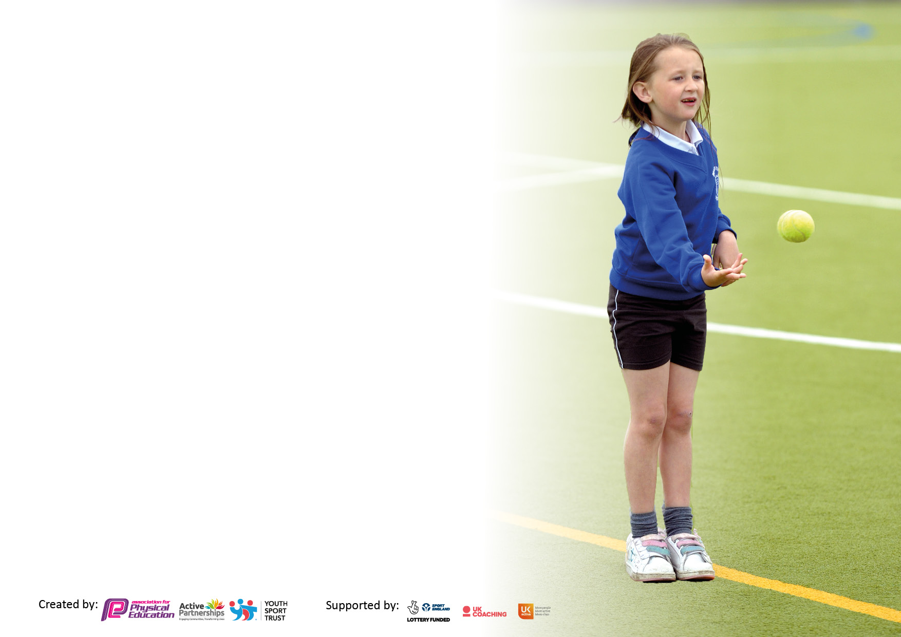

It is important that your grant is used effectively and based on school need. The Education Inspection Framework makes clear there will be a focus on **‘whether leaders and those responsible for governors all understand their respective roles and perform these in a way that enhances the effectiveness of the school’**.

Under the Quality of Education Ofsted inspectors consider:

**Intent** - Curriculum design, coverage and appropriateness

**Implementation** - Curriculum delivery, Teaching (pedagogy) and Assessment

**Impact** - Attainment and progress

To assist schools with common transferable language this template has been developed to utilise the same three headings which should make your plans easily transferable between working documents.

Schools must use the funding to make **additional and sustainable** improvements to the quality of Physical Education, School Sport and Physical Activity (PESSPA) they offer. This means that you should use the Primary PE and sport premium to:

* Develop or add to the PESSPA activities that your school already offer
* Build capacity and capability within the school to ensure that improvements made now will benefit pupils joining the school in future years
* The Primary PE and sport premium should not be used to fund capital spend projects; the school’s budget should fund these.

We recommend you start by reflecting on the impact of current provision and reviewing the previous spend.

Schools are required to publish details of how they spend this funding, including any under-spend from 2021/2022, as well as on the impact it has on pupils’ PE and sport participation and attainment. **All funding must be spent by 31st July 2023.**

We recommend regularly updating the table and publishing it on your website throughout the year. This evidences your ongoing self-evaluation of how you are using the funding to secure maximum, sustainable impact. Final copy must be posted on your website by the end of the academic year and no later than the 31st July 2023. To see an example of how to complete the table please click HERE.

Created by: Supported by:

**Details with regard to funding**

Please complete the table below.

|  |  |
| --- | --- |
| Total amount carried over from 2021/22 | £0 |
| Total amount allocated for 2022/23 | £19,000 |
| How much (if any) do you intend to carry over from this total fund into 2002/23? | £0 |
| Total amount allocated for 2022/23 | £19,000 |
| Total amount of funding for 2022/23. To be spent and reported on by 31st July 2023. | £19,000 |

**Swimming Data**

Please report on your Swimming Data below.

|  |  |
| --- | --- |
| Meeting national curriculum requirements for swimming and water safety.  N.B. Complete this section to your best ability. For example you might have practised safe self-rescue techniques on dry land which you can then transfer to the pool when school swimming restarts.  **Due to exceptional circumstances priority should be given to ensuring that pupils can perform safe self-rescue even if they do not fully meet the first two requirements of the NC programme of study** |  |
| What percentage of your current Year 6 cohort swim competently, confidently and proficiently over a distance of at least 25 metres?  **N.B.** Even though your pupils may swim in another year please report on their attainment on leaving primary school at the end of the summer term 2023.  Please see note above | 55% |
| What percentage of your current Year 6 cohort use a range of strokes effectively [for example, front crawl, backstroke, and breaststroke]?  Please see note above | 25% |
| **What percentage of your current Year 6 cohort perform safe self-rescue in different water-based situations?** | 25% |
| Schools can choose to use the Primary PE and sport premium to provide additional provision for swimming, but this must be for activity **over and above** the national curriculum requirements. Have you used it in this way? | No |

**Action Plan and Budget Tracking**

Capture your intended annual spend against the 5 key indicators. Clarify the success criteria and evidence of impact that you intend to measure to evaluate for pupils today and for the future.

|  |  |  |  |  |
| --- | --- | --- | --- | --- |
| **Academic Year:** 2022/23 | **Total fund allocated:** | **Date Updated: July 2022** | |  |
| **Key indicator 1:** The engagement of all pupils in regular physical activity – Chief Medical Officers guidelines recommend that primary school pupils undertake at least 30 minutes of physical activity a day in school | | | | Percentage of total allocation: |
| 10.5% -1995 |
| **Intent** | **Implementation** | | **Impact** |  |
| **Your school focus should be clear what you want the pupils to know and be able to do and about**  **what they need to learn and to**  **consolidate through practice:** | **Make sure your actions to achieve are linked to your intentions:** | **Funding allocated:** | **Evidence of impact: what do pupils now know and what can they now do? What has changed?:** | **Sustainability and suggested next steps:** |
| Children given skills to lead as Lunchtime Play Leaders and take an active role towards the application for the Bronze Sports Mark.  Varying sport equipment availed during lunch break for pupils to independently explore skills learned during physical education lessons.  Lunchtime sporting clubs in place every day led by Sports Coach to support wellbeing and physical activity.  Children are encouraged to walk to and from school to support with increased physical activity of all pupils. | After applications assessed training will be provided for Lunchtime Play Leaders to promote sport in school .  Play leaders to take an active role in different sports activities with the support of adults on duty.  An overview of additional sporting activities in place and allocated to children to support both physical and mental health.  This is promoted by the Play Leaders within newsletters and assemblies. | £2,000 | Behaviour lead and Well Being Coach lead the Play Leaders which are now firmly established in the school. Children have responsibilities for leading games outside, as well as supporting younger children in the dining hall.  Lunchtime sports equipment has been replenished regularly throughout the year to encourage a variety of skills and games to be played, both on the playground and field.  Sports coaches lead la variety of lunchtime sessions for children every day including basketball, athletics, dance and football.  School took part in ‘Walk to School Week’ led by the PE lead. The impact of which was significant with more children walking to school and children working collaboratively towards a class certificate awarded in assembly. | Year 5 playleaders to support the new playleaders applying in September 23 by mentoring them.  Regular meetings with WBT to ensure expectations remain high and children are trained to fulfil their roles with confidence.  Sports coaches to continue to lead lunchtime clubs in 23-24.  WBP to work towards gaining the Bronze Sports mark next year, building upon the firm foundations established this year.  WBP to be part of the Thamesmead ‘Superzones’ programme in 23-24 in which the streets surrounding the school will be a focus for community improvements such as ‘no smoking zones’ to encourage more children to walk to school. |
| **Key indicator 2:** The profile of PESSPA being raised across the school as a tool for whole school improvement | | | | Percentage of total allocation: |
| 15.7% |
| **Intent** | **Implementation** | | **Impact** |  |
| **Your school focus should be clear what you want the pupils to know and be able to do and about**  **what they need to learn and to**  **consolidate through practice:** | **Make sure your actions to achieve are linked to your intentions:** | **Funding allocated:** | **Evidence of impact: what do pupils now know and what can they now do? What has changed?:** | **Sustainability and suggested next steps:** |
| To provide children with the skills  and opportunities to use a range of  sports skills in different contexts.  Share sporting achievements across the school. | Experienced PE sports coach employed to lead outdoor PE lessons across the school, lunchtime and after school clubs as well as model sessions and team teach.  Success achieved during sporting events will be shared in class, whole school assemblies and newsletters with parents to encourage continued engagement of physical activities within and outside the school.  Award successes with badges, certificates or opportunities to share experiences with the rest of the school. | £3,000 | PE coaches have led sessions across the year in all year groups developing children’s skills in a variety of ball games including basketball, netball, cricket, rounders as well as tag rugby, gymnastics and dance.  Free after school clubs have taken place every Tuesday and Wednesday for children in Years 1-6 and will continue next year.  Weekly parent newsletters celebrate children’s learning and achievements in PE every half term.  EYFS/KS1 and KS2 sports days took place this year, with children earning house points for their houses. Field events took part at lunchtimes led by Sports Ambassadors with traditional races held on the sports days. | With three ECTs joining the school in 23-24 plus a teaching apprentice, they will have opportunities to observe the PE coaches teach indoor and outdoor sessions to improve their own skills and knowledge in PE.  We would like to organise sports events across the WAT e.g. football, netball, cricket/rounders matches to extend children’s experiences of playing for a school team. |

|  |  |  |  |  |
| --- | --- | --- | --- | --- |
| **Key indicator 3:** Increased confidence, knowledge and skills of all staff in teaching PE and sport | | | | Percentage of total allocation: |
| 58% |
| **Intent** | **Implementation** | | **Impact** |  |
| **Your school focus should be clear** | **Make sure your actions to** | **Funding** | **Evidence of impact: what do** | **Sustainability and suggested** |
| **what you want the pupils to know** | **achieve are linked to your** | **allocated:** | **pupils now know and what** | **next steps:** |
| **and be able to do and about** | **intentions:** |  | **can they now do? What has** |  |
| **what they need to learn and to** |  |  | **changed?:** |  |
| **consolidate through practice:** |  |  |  |  |
| Teachers are provided with CPL through the deployment of specialist teachers.  Medium- and short-term plans in place to support the sequence of teaching and skills within each area of the curriculum. | Teachers are provided with opportunities to observe outstanding practice and develop their practice.  Staff are provided with opportunities to review lesson sequences on PE passport and review based on the needs of the children. | £11,000 | Teachers are encouraged to observe experienced sports coaches to develop their own practice.  Planning was followed and monitored by PE lead to ensure progression and coverage of the curriculum. PE assessments also completed half termly to track children’s progress and identify gaps in skills to weave into planning. | PE CPD sessions to be planned across the academic year to provide staff with skills and knowledge to teach high quality PE sessions.  PE lead is leaving at the end of the year. SLT to lead PE next year, shadowed by an ECT to give them experience of subject leadership. |
| **Key indicator 4:** Broader experience of a range of sports and activities offered to all pupils | | | | Percentage of total allocation: |
| 13% |
| **Intent** | **Implementation** | | **Impact** |  |
| **Your school focus should be clear** | **Make sure your actions to** | **Funding** | **Evidence of impact: what do** | **Sustainability and suggested** |
| **what you want the pupils to know** | **achieve are linked to your** | **allocated:** | **pupils now know and what** | **next steps:** |
| **and be able to do and about** | **intentions:** |  | **can they now do? What has** |  |
| **what they need to learn and to** |  |  | **changed?:** |  |
| **consolidate through practice:** |  |  |  |  |
| Pupils to access after school clubs to develop both physical and mental health.  Targeted groups in place to further develop the wellbeing of all children.  Use award programmes such as Children’s University to encourage children to get involved in lots of exciting activities including physical activities. | An overview of clubs for the year in place which provide a broad and balanced overview of the PE curriculum with opportunities for all year groups. Clubs to be subsidised to ensure all children have equal access.  Pupils identified by the wellbeing team with support modelled around need and interests of the pupils.  Children participating in physical activities within or outside the school will be able to earn a stamp and with enough stamps graduate at the end of the academic year. | £2,500 | Free after school clubs provided across the year for children in Y1-6 . A variety of clubs provided to cover a range of interests for each year group.  Youth Engagement Team have provided a basketball club this year for a targeted group of UKS2 children to support with their transition to secondary school and social development.  PE lead organised fencing workshops for UKS2 classes and a special assembly to introduce the children to the sport. Classes were also offered to parents.  Two children graduated this year from CU earning points from physical activities as well as other curriculum areas. | Free after school clubs will continue in 2023 2024 (twice weekly) lead by sports coaches, supplemented by clubs provided by the Youth Engagement service e.g. basketball for UKS2 children to support with transition.  YET to continue providing support via sports clubs and mentoring in 23 24.  School to raise the profile of CU next year to encourage more children to participate in the range of activities on offer. This will be via assemblies, presence at parents’ evenings, parent coffee mornings etc. |

|  |  |  |  |  |
| --- | --- | --- | --- | --- |
| **Key indicator 5:** Increased participation in competitive sport | | | | Percentage of total allocation: |
| 2.6% |
| **Intent** | **Implementation** | | **Impact** |  |
| **Your school focus should be clear** | **Make sure your actions to** | **Funding** | **Evidence of impact: what do** | **Sustainability and suggested** |
| **what you want the pupils to know** | **achieve are linked to your** | **allocated:** | **pupils now know and what** | **next steps:** |
| **and be able to do and about** | **intentions:** |  | **can they now do? What has** |  |
| **what they need to learn and to** |  |  | **changed?:** |  |
| **consolidate through practice:** |  |  |  |  |
| Children are provided with competitive opportunities both within and out with school.  Encourage active participation for all the children in competitive sports especially those who are mostly inactive. | Inter-Trust Competitions in place and reflect the current PE curriculum. Opportunities for competitive sports are identified and children are provided with additional coaching to support with this.  Keep a record of participants during sporting events to ensure that all pupils not just the active ones participate. | £500 | Children took part in a football match with Harris Garrard academy in the autumn term.  Behaviour Lead runs a sports coach intervention programme to support several children with SEMH to develop their communication skills and self-confidence. This has had a positive impact on their behaviour in the classroom and on the playground.  School have been awarded a girls’ team football kit by the Premier League Primary Stars Kit Scheme 2023 which will be delivered in spring 2024. This will enable us to set up a girls’ football team next academic year and organise friendly matches with neighbouring schools. | To further develop school teams e.g. football, netball, cricket etc to enable children to experience competitive team games with other schools.  To make links with local sports clubs to encourage our children to participate in a variety of sporting activities outside of school. |

|  |  |
| --- | --- |
| Signed off by | |
| Head Teacher: | Abi Oldfield |
| Date: | 21st July 2023 |
| Subject Leader: | Millicent Omollo |
| Date: | 21st July 2023 |
| Governor: | Ashley Brett (LAC Curriculum) |
| Date: | 21st July 2023 |