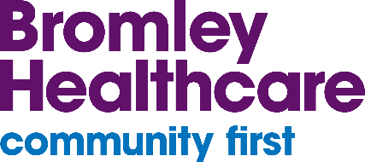
February / March 2024

Tri-borough SEND Newsletter
Bromley Healthcare provides Special Educational Needs and Disabilities (SEND) support to people living in Bromley, Bexley and Greenwich, in partnership with other key professionals and networks.
-
Welcome to the latest edition of the Tri-borough SEND Newsletter! We aim to publish these to you every 4 to 6 weeks.

National Primary Care Pathway for Constipation in Children
Video Introduction and overview to constipation in children | YouTube
The National Primary Care Clinical Pathway for Constipation in Children gives advice to clinicians on how to prevent and manage constipation in children and young people. This is done in a clear and standardised approach, based on guidelines from the National Institute for Health and Care Excellence (NICE), the British National Formulary for Children (BNFc) and clinical expert groups.
The pathway makes sure that clinicians, families and other care providers can easily access available resources. It also raises the profile of constipation in children and young people with a learning disability as a factor in adult mortality rates. NHS National Primary Care Clinical Pathway for Constipation in Children | PDF (england.nhs.uk)

Parent / Carer and Professional ADHD Support
Video Let's talk about ADHD | YouTube
ADHD Embrace helps parents, carers and professionals who work with children and young people with ADHD. They give information, advocate for people and empower them to help improve the lives of children and young people with ADHD and their families. Welcome | ADHD Embrace

Learn about Eating Disorders
Video Eating Disorders Awareness Week 2024: Joe’s Story | YouTube
Beat are the UK’s eating disorder charity. Their mission is to end the pain and suffering caused by eating disorders.
Eating disorders are complex mental illnesses. Anyone, regardless of age, gender, ethnicity or background, can develop one. Learn about eating disorders | Beat Eating Disorders
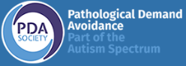 | Pathological Demand Avoidance (PDA) Society  Video What is PDA? | YouTube  The PDA Society is a charity in the UK who help people with Pathological Demand Avoidance (PDA).  Find information, training and support for PDA people, parents & carers, and professionals on their website: Home | PDA Society – Pathological Demand Avoidance

Useful resources
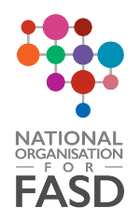 | Fetal Alcohol Spectrum Disorder (FASD)  Video FASD - Alcohol in Pregnancy | YouTube  Fetal Alcohol Spectrum Disorder (FASD) happens when a baby is exposed to alcohol before birth, affecting the developing brain and body. FASD is a spectrum and affects each person differently and is a lifelong neurodevelopmental condition.  Information and resources for children and young people, parents, carers, and professionals can be found at: Learn More | National FASD

Medicines for Children
Video Welcome to Medicines for Children | YouTube
Medicines for Children gives practical and reliable advice about giving medicines to children. Home | Medicines For Children

World Down Syndrome Day 2024
Celebrate Down Syndrome on Thursday 21 March 2024!
Follow the link and see how we can all help to make this World Down Syndrome Day, the biggest and best yet: Home | DSUK - Down Syndrome UK

Disability and Accessibility Events
As a pan-disability charity, AbilityNet have created a Disability and Accessibility Events Calendar to support other organisations and highlight the role of technology in helping people with all types of disabilities and conditions.
Disability and accessibility-related events calendar | AbilityNet

Tri-borough Local Offers
The Local Offer is a document that gives information about the support services available in your local area. This specifically for children, young people and their families with Special Educational Needs and / or Disabilities (SEND).
About the Bromley Local Offer | London Borough of Bromley
Home | Bexley Local Offer
About the Local Offer | Royal Borough of Greenwich

Get to Know Your Local Children and Family Centres
Royal Borough of Greenwich Children's centres | Royal Borough of Greenwich
Bexley About the Children's Centres | London Borough of Bexley
Bromley Children and Family Centres (bromley.gov.uk)
Should your you require any further support or information, please contact the Health Visiting Tri-borough SEND Specialists at:
Contact: bromh.tri-boroughsendchampions@nhs.net
Please also follow us at the following social media platforms:
@Bexley0to19  @Bromley0to19  @Greenwich0to4 |  | Bexley 0 to 19  Bromley 0 to 19  Greenwich 0 to 4 | @bexley_0to19  @bromley_0to19  @greenwich_0to4
We want to hear your feedback on our services. Visit careopinion.org.uk/youropinion.

