Tuesday 12th September 2023

Re: Meet the Teacher session Wednesday 20th September 2023

Dear Parents and Carers,
We hope you have all had an enjoyable and relaxing summer break. The children have come back to school refreshed and ready to learn and have made a really positive start to the new academic year.

We will be holding an informal ‘Meet the Teacher’ session on Wednesday 20th September from 3:30 – 4:00pm to give you an opportunity to meet your child’s new teacher and teaching assistant in their new classroom and also to receive important information regarding class routines and timetables, the core text being used this term as well as other curriculum information to enable you to support your child’s learning at home.

Children will be handed over to parents as usual at the end of the day at 3:20pm, and you are then invited to return to your child’s classroom for the Meet the Teacher session. We hope you are able to attend as the value of parental encouragement and support for learning cannot be underestimated.

All class presentations will be uploaded onto the school website following the sessions so if you have several children attending the school, you will be able to access the information if you are unable to attend every session. Paper copies of the presentation slides will also be available in classrooms.

We would like to take this opportunity to thank you for your on-going support and look forward to seeing you all.

Best wishes,
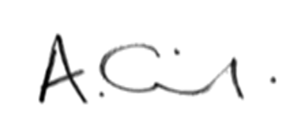
Mrs Oldfield
Headteacher

