Date: 02.04.24
YEAR 6 LEAVERS HOODIES

Dear Parents/Guardians,

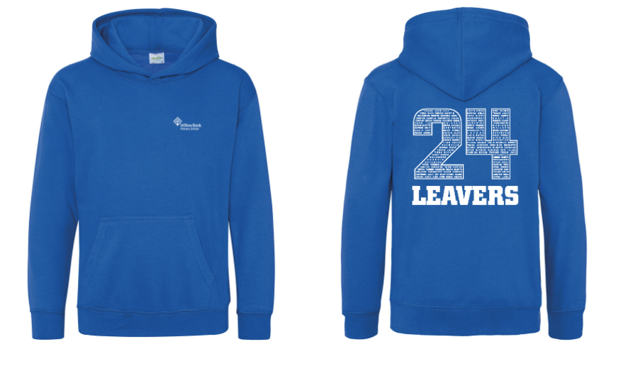
With just a few months remaining until our current year 6 begin the next stage of their educational journey at secondary school, we thought it would be nice for the children to have a memento of their time at Willow Bank.

We would like to organise leavers hoodies to be printed for every child: each hoodie will include the Willow Bank Primary School badge printed on the front and a Leavers 24 design, with names inside the numbers, printed on the back - an example of the hoodies is shown.

The hoodies are 80% Ringspun Cotton / 20% Polyester and cost £18 each. All ordered are to be placed via the online link:
https://shop.teamhoodies.co.uk/willowbank24/

Please make your order by the 30^{th of} June.
If you have any difficulty with ordering, please contact the school.

Yours sincerely,

Mr Poole and Mr Ali

Year 6 teachers

