Reception: Summer 2 | Key Dates
Reception Summer 2 – Reach for the Stars  Topic Overview  In Summer 2, children in Reception will explore their aspirations for their transition into Year 1 through different texts encouraging a growth mindset. They will discuss the troubles the characters have in the stories and how they teach valuable lessons the children can take into their own lives. During Arts Fortnight, Reception will be focusing on the era of the 1990’s to explore artists, music and culture of this decade. | Friday 4th July – WBP Festival  Thursday 17th July – Reception graduation 2-3pm  Tuesday 22nd July - Last day of term  Parent reading morning every Thursday 8:40-9:10am.


Areas of Learning | Literacy – Writing | Children will write a recount, where they write about something that has happened. They will learn to use words like first, next, then, and finally to tell the story in the right order. For example:  - First, Gerald the giraffe wanted to dance.  - Next, he felt sad because the other animals laughed at him.  - Finally, Gerald found his own special way to dance and everyone joined in. | Core Text  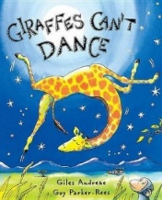  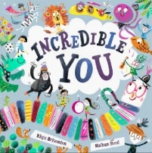  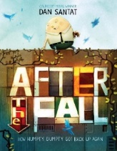    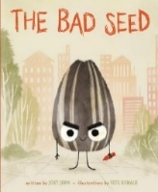
 | Literacy - Reading & Phonics | During the summer term, Reception will continue to consolidate their phase 3 sounds through their phase 4 learning. They will read familiar words with the suffixes -s, -es,-ing and -ed and reading cvvc words.
 | Maths | In Maths, Reception will look at numbers beyond 20, the beginnings of addition and subtraction and will further develop their knowledge of shapes by creating pictures using 2D shapes they already know.
 | Understanding the World | Reception will be revisiting their understanding the world learning this year through their key texts. They will look at materials, different countries and habitats and growing through planting seeds.
 | Expressive Art and Design | During this half term Reception children will have the opportunity to manipulate materials for a planned effect. They will also be encouraged to join in with songs and learn through rhymes. In continuous provision, children will be able to explore joining materials and create artwork related to their texts.
 | Personal, Social, Emotional Development | During this half term children will continue to demonstrate friendly behaviour, initiate conversations and consolidate good relationships with peers and adults. Reception will continue to understand and follow behaviour expectations in the classroom. Children will develop confidence when talking to other children when playing and will talk confidently during carpet sessions.
 | Physical Development | We will be focusing on developing the children's athletic stills through sports day. In their PE sessions children will learn associated skills for running, jumping and using different obstacles to complete an obstacle course.
 | Communication & Language | During continuous provision, children will have the opportunity talk and ask questions, developing their vocabulary. This will be facilitated through exploring the natural world inside and out of school.

